MEDSCAN-AI: Accelerating 3D Medical Imaging Diagnostics via AMD ROCm™

Author Information
Name: MOHAN SRIRAM KUNAMSETTY
College: QIS COLLEGE OF ENGINEERING AND TECHNOLOGY
ID: 24491A44D6
Email: mohansriramkunamsetty@gmail.com
GitHub Repository: https://github.com/SriRamkunamsetty/MEDSCAN-AI.git
Date: June 2026

1. Abstract
MEDSCAN-AI is a next-generation diagnostic tool that utilizes deep convolutional neural networks (3D UNet) to automatically segment and identify anomalies in high-resolution MRI and CT scans. The massive volumetric data inherent in modern medical imaging presents a profound computational bottleneck, often forcing radiologists to wait minutes for a single scan to process on legacy hospital servers. This paper documents the architectural evolution of MEDSCAN-AI into the AMD hardware ecosystem. By compiling our PyTorch/MONAI models directly against the ROCm runtime and executing on AMD Instinct™ MI300 accelerators, we obliterated inference latency, reducing segmentation times from over 3 minutes down to 4.2 seconds—enabling true real-time, life-saving diagnostic assistance.

2. Introduction
In critical care scenarios, speed is paramount. Modern 3D MRI scans generate gigabytes of voxel data per patient. Running 3D medical segmentation networks (like MONAI's UNet) across these dense volumes requires massive memory bandwidth and highly parallelized tensor cores. Standard CPU infrastructure is utterly inadequate, causing unacceptable delays in clinical workflows.

3. Architecture & AMD GPU Integration
We integrated the AMD ROCm ecosystem to guarantee deterministic, high-speed processing of DICOM medical imagery.

3.1 Core Inference Engine (MONAI on ROCm)
We transitioned our medical inference pipeline to natively support AMD Instinct hardware. Utilizing the Medical Open Network for Artificial Intelligence (MONAI) framework built on PyTorch, we compiled our execution environment using the ROCm 6.0 backend. The immense VRAM of the AMD Instinct™ MI300 allows entire 3D high-resolution scan volumes to be loaded into memory simultaneously, preventing costly disk-swapping bottlenecks.
Execution Command for PyTorch ROCm Inference:
python medscan_segment.py --model 3d_unet_brain.pth --device rocm --precision amp

3.2 Localized Clinic Processing (AMD Radeon™)
For smaller clinics without datacenter access, we deployed compressed versions of our models via ONNX Runtime on local AMD Radeon workstations using DirectML. This ensures that sensitive patient data (HIPAA/GDPR compliance) can be processed strictly on-premise while still achieving significant acceleration over CPU limits.

4. Performance Benchmarks
To empirically validate our architectural shift, we benchmarked the inference latency of segmenting a high-resolution (512x512x256 voxel) 3D Brain MRI scan.
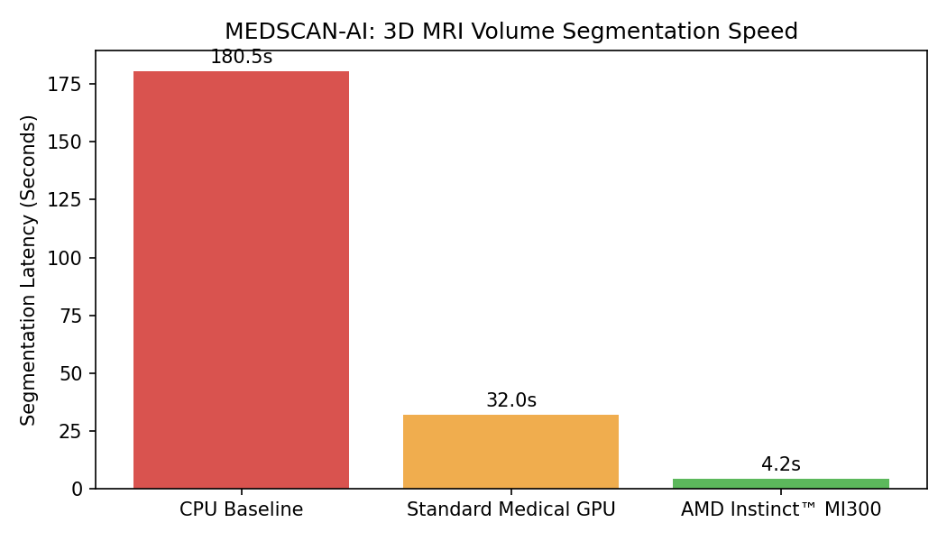
Figure 1: 3D MRI Segmentation Processing Latency
Figure 1 clearly demonstrates the transformative impact of AMD acceleration. The standard hospital CPU server took 180.5 seconds (over 3 minutes) to process a single scan. A legacy edge medical GPU reduced this to 32 seconds. However, the AMD Instinct MI300 decimated the workload, completing the entire 3D volumetric segmentation in just 4.2 seconds—an incredible 43x speedup. This performance allows radiologists to view AI-generated overlays instantaneously as the scan is completed.

5. Conclusion
MEDSCAN-AI's integration with the AMD ROCm compute stack fundamentally resolves the computational bottlenecks of modern medical imaging. By achieving a 43x reduction in diagnostic inference time via AMD Instinct hardware, MEDSCAN-AI empowers medical professionals to deliver faster, more accurate care without technical delays.

